SOC Analyst Project

IDS Log Analysis, Monitoring & Visualization Using Splunk

Project Overview
A hands-on SOC project focused on analyzing Intrusion Detection System (IDS) logs to detect and monitor security threats. Raw IDS events generated by Suricata were analyzed in Splunk using custom SPL queries and security dashboards to identify intrusion attempts, alert severity, scanning behavior, and attack patterns.

Key Skills Demonstrated
- IDS Log Analysis (Suricata)
- SIEM Monitoring & SPL Queries
- Alert Triage & Threat Detection
- Security Dashboards & Visualization
- SOC Analyst (L1) Workflow

Tools & Technologies
- Suricata | Splunk | SPL | Linux | Kali Linux

Prepared By
Swarupananda Das
Aspiring SOC Analyst | Cybersecurity Enthusiast

INDEXING

- Project Objective…………………………………………………………………….. 3
- Tools & Technologies Used………………………………………………………. 4
- Monitoring Posture Design……………………………………………………… 6
- IDS Log Analysis Fundamentals for SOC Analysts……………………. 12
- IDS Event Breakdown (Suricata Raw Log Analysis)………………….. 14
- Operational IDS Monitoring Through SPL Query Execution…….. 15
- Alert Triage and Threat Visualization Using IDS Dashboards….. 17
- Security Monitoring Limitation and Mitigation………………………. 19
- Incident Analysis Summary……………………………………………………… 19
- SOC Analyst Actions During IDS Alert Investigation……………… 20
- SOC Escalation and Handover Process………………………………… 21
- Conclusion…………………………………………………………………………… 21

Project Objective
SOC Analyst Project: IDS Log Analysis, Monitoring & Visualization Using Splunk
Primary Objective
The primary objective of this project is to analyze Intrusion Detection System (IDS) logs using Splunk to identify, monitor, and visualize potential security threats in a simulated Security Operations Center (SOC) environment.

Detailed Objectives
- To collect and ingest IDS log data into Splunk for centralized security monitoring.
- To analyze IDS alerts and events in order to detect suspicious activities such as intrusion attempts, malicious IP addresses, and abnormal network behavior.
- To write and execute SPL (Search Processing Language) queries to extract meaningful security insights from raw IDS logs.
- To identify attack patterns and threat indicators including source IP, destination IP, attack type, severity, and frequency.
- To create interactive dashboards and visualizations for real-time monitoring and incident analysis.
- To simulate a SOC Analyst (L1) workflow, including alert investigation, log correlation, and threat validation.
- To enhance incident visibility and improve decision-making by transforming raw security data into actionable intelligence.
- To demonstrate hands-on SOC skills aligned with real-world security monitoring and detection use cases.

Outcome of the Project
This project demonstrates practical experience in:
- IDS log analysis
- SIEM monitoring
- Threat detection & visualization
- SOC Analyst operational workflow

Tools & Technologies Used
IDS: Snort / Suricata
Snort / Suricata are network-based Intrusion Detection Systems (IDS) used to monitor network traffic and detect suspicious or malicious activities.
They generate alerts based on predefined rules and signatures, which help identify potential attacks such as port scans, brute-force attempts, and malware traffic.
SIEM: Splunk
- Splunk is used as a Security Information and Event Management (SIEM) tool to collect, store, and analyze IDS log data.

- It helps correlate security events, perform log analysis, and visualize threats through dashboards for effective SOC monitoring.
SPL (Search Processing Language)
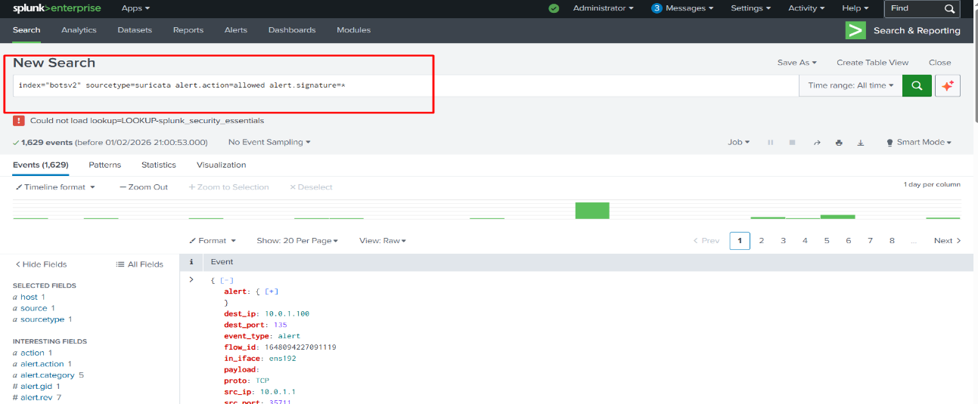
- SPL is the query language used in Splunk to search, filter, and analyze large volumes of IDS log data.
- It enables the extraction of key security information such as source IP, destination IP, alert type, severity, and event count.
Operating System: Kali Linux / Linux
- Kali Linux is a Linux-based operating system commonly used for cybersecurity testing and security labs.
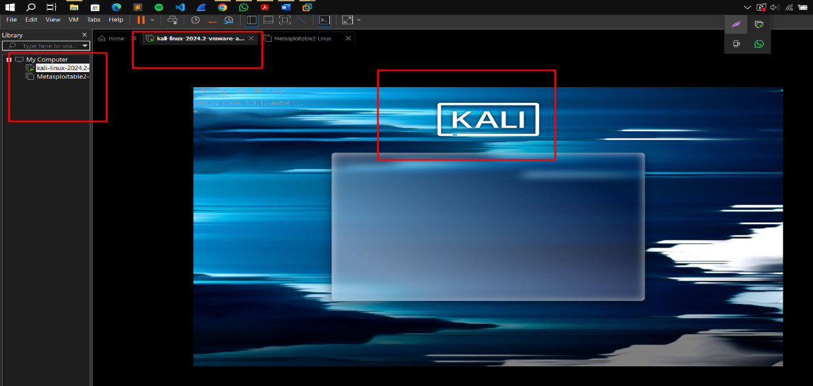
- It provides a stable environment to simulate attacks, generate IDS alerts, and test detection and monitoring scenarios.

Log Type: IDS Alerts (Network-Based)
- The project focuses on network-based IDS alert logs, which record suspicious activities detected in network traffic.
- These logs include information such as timestamps, source and destination IPs, protocol details, and alert messages used for threat analysis.

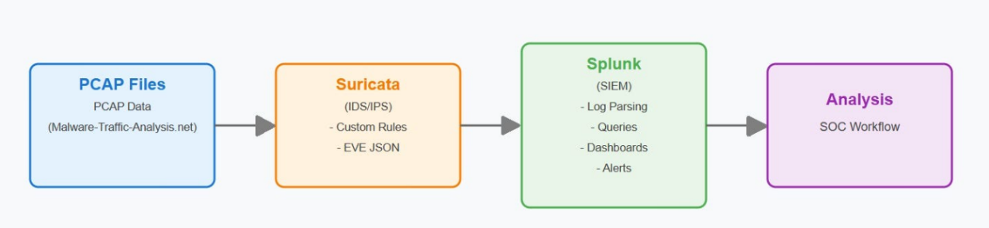

Monitoring Posture Design
- I designed an IDS monitoring posture in Splunk by creating structured SPL queries and dashboards to continuously monitor intrusion attempts, alert severity, attack sources, and scanning behavior.
- The dashboard is divided into multiple security-focused sections, allowing SOC analysts to quickly detect, prioritize, and investigate IDS alerts.
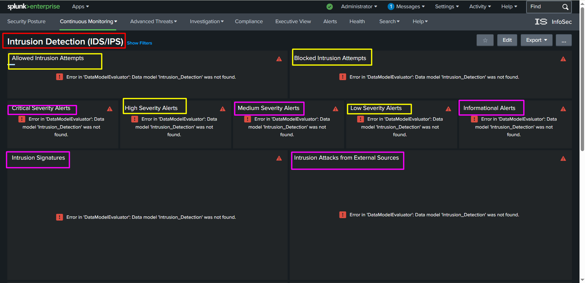
- This monitoring posture simulates a real SOC environment where visibility, alert triage, and threat identification are critical.

Allowed Intrusion Attempts
- This section monitors IDS alerts where intrusion attempts were detected but not blocked by security controls.
- It helps identify suspicious activities that may bypass preventive mechanisms and require further investigation.
- SOC analysts use this view to validate false positives and assess potential policy gaps.
SPL Command: index="botsv2" sourcetype=suricata alert.action=Allowed alert.signature=* |stats count(action)
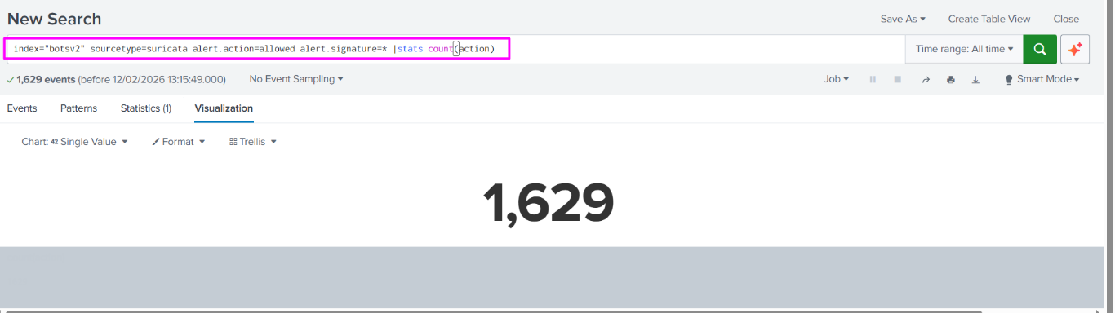
Blocked Intrusion Attempts
- This panel displays intrusion attempts that were successfully blocked by IDS or security rules.
- It provides visibility into active defense mechanisms and confirms that detection rules are working as expected.
- Monitoring blocked attempts helps analysts understand attack frequency and attacker behavior.
- SPL Command: index="botsv2" sourcetype=suricata alert.action=Blocked alert.signature=* |stats count(action)
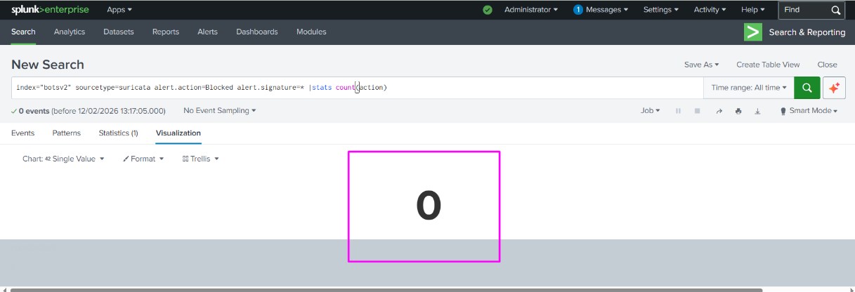

Critical Severity Alerts
- This section focuses on high-impact IDS alerts that indicate serious security threats.
- These alerts require immediate attention due to the potential risk to systems or network infrastructure.
- SOC analysts prioritize investigations based on this panel to reduce incident response time.
SPL Command: index="botsv2" sourcetype=suricata alert.signature=* alert.severity=1 | stats count(alert.signature)
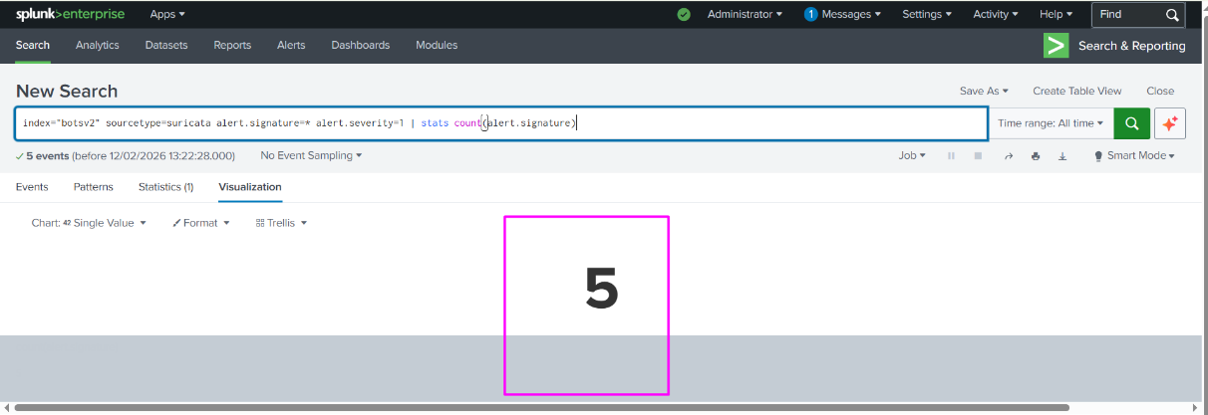

High Severity Alerts
- High severity alerts represent significant threats that could lead to compromise if ignored.
This panel helps analysts identify dangerous attack patterns such as exploit attempts or repeated intrusion attempts.
- It supports effective alert prioritization in a SOC environment.
SPL Command: index="botsv2" sourcetype=suricata alert.signature=* alert.severity=2 | stats count(alert.signature)
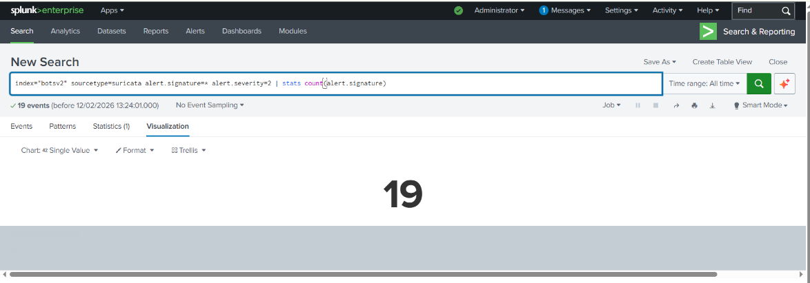

Medium Severity Alerts
- This section displays alerts that indicate suspicious but not immediately critical activity.
Such alerts may represent reconnaissance, scanning, or early-stage attacks.
- Analysts monitor these events to detect patterns that may escalate into serious incidents.
SPL Command: index="botsv2" sourcetype=suricata alert.signature=* alert.severity=3 OR alert.severity=medium | stats count(alert.severity)
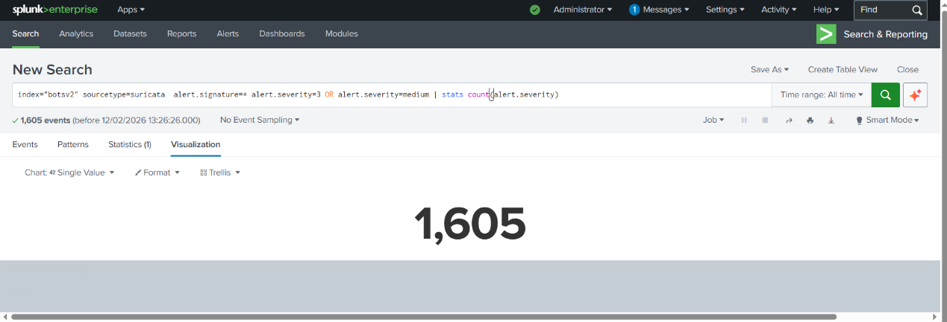

Low Severity Alerts
- Low severity alerts include minor or policy-based detections that pose minimal immediate risk.
- Although not urgent, these alerts help maintain full visibility of network activity.
- They are useful for tuning IDS rules and reducing false positives.
SPL Command: index="botsv2" sourcetype=suricata alert.signature=* alert.severity=4 | stats count(alert.severity)

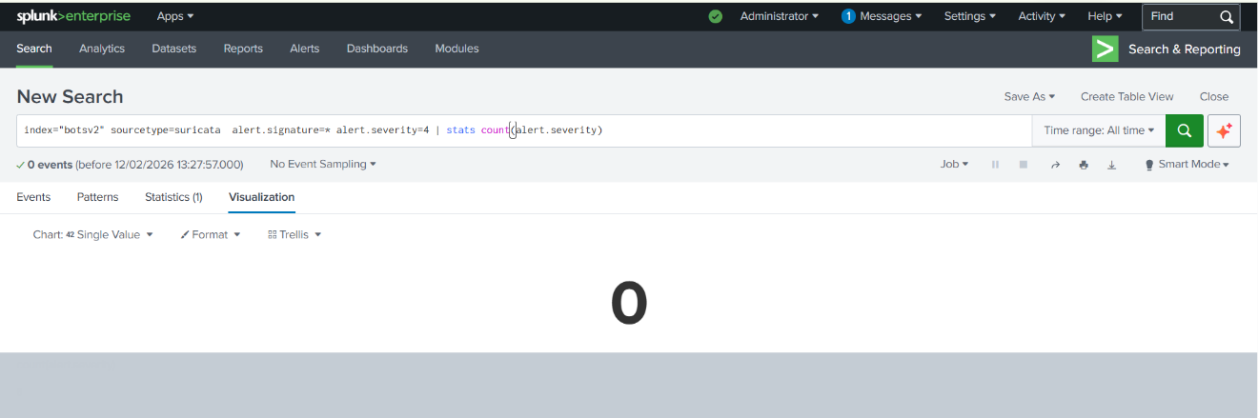
Informational Alerts
- This panel contains informational IDS alerts related to normal or expected network behavior.
- It helps analysts differentiate between benign activity and real threats.
- Monitoring informational alerts improves contextual awareness in SOC operations.
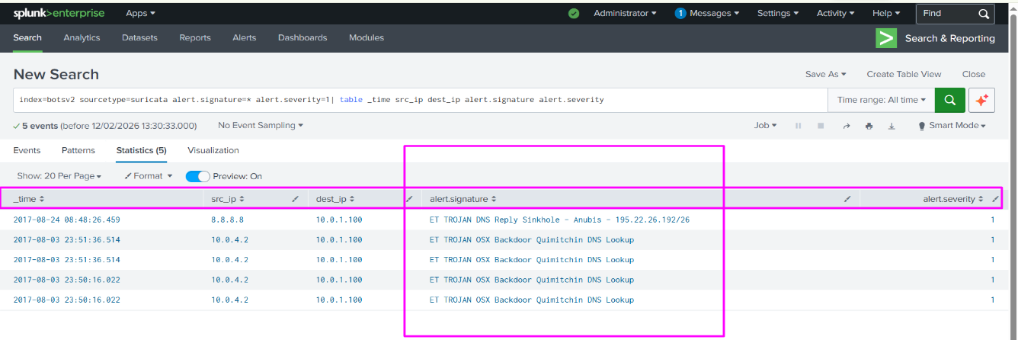
SPL Command: index=botsv2 sourcetype=suricata alert.signature=* alert.severity=1| table _time src_ip dest_ip alert.signature alert.severity

Intrusion Signatures
- This section highlights the IDS signatures or rules that triggered alerts.
- It helps identify the type of attacks detected, such as port scans, brute-force attempts, or exploit signatures.
- Analysts use this information to understand attacker techniques and improve detection rules.
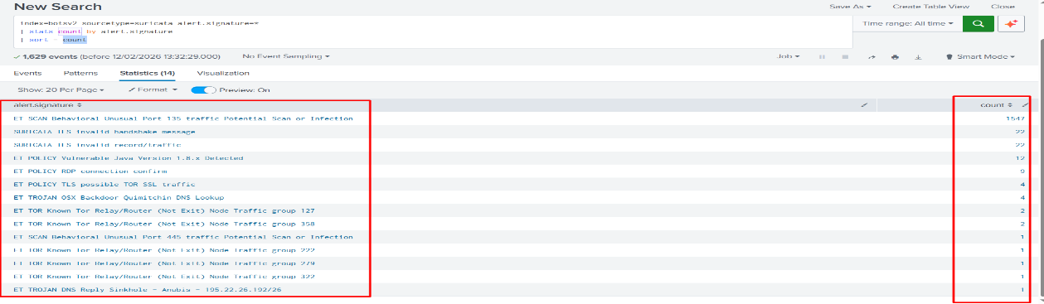
SPL Command : index=botsv2 sourcetype=suricata alert.signature=*| stats count by alert.signature| sort - count

Intrusion Attacks from External Sources
- This panel focuses on intrusion attempts originating from external or untrusted networks.
- It helps identify external threat actors targeting the internal infrastructure.
- Such visibility is critical for perimeter defense and threat hunting activities.
SPL Command: index=botsv2 sourcetype=suricata alert.signature=*
| where NOT (
cidrmatch("10.0.0.0/8", src_ip) OR
cidrmatch("172.16.0.0/12", src_ip) OR
cidrmatch("192.168.0.0/16", src_ip)
)
| table _time src_ip dest_ip alert.signature alert.severity
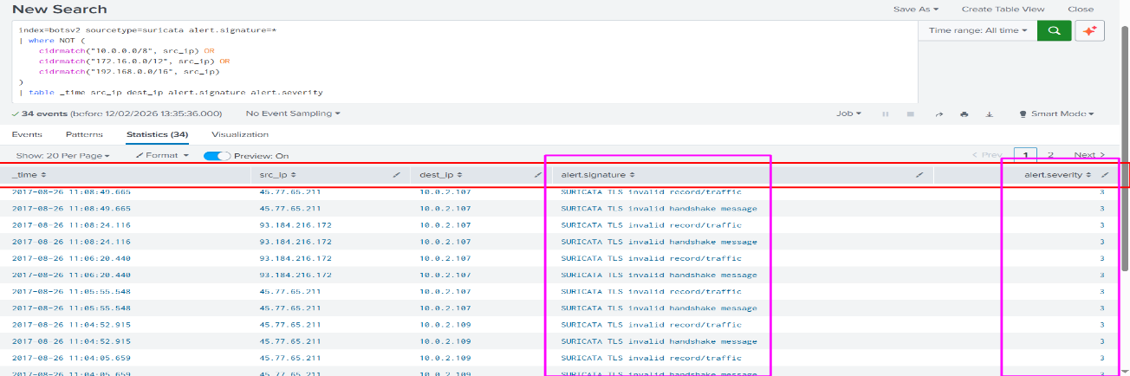
Intrusion Alerts by Signature
- This section visualizes the frequency of alerts based on IDS signatures.
- It helps SOC analysts identify the most common attack types in the environment.
- Frequent signatures may indicate ongoing attack campaigns or misconfigured rules.
SPL Command: index=botsv2 sourcetype=suricata alert.signature=* | stats count by alert.signature alert.severity | sort – count
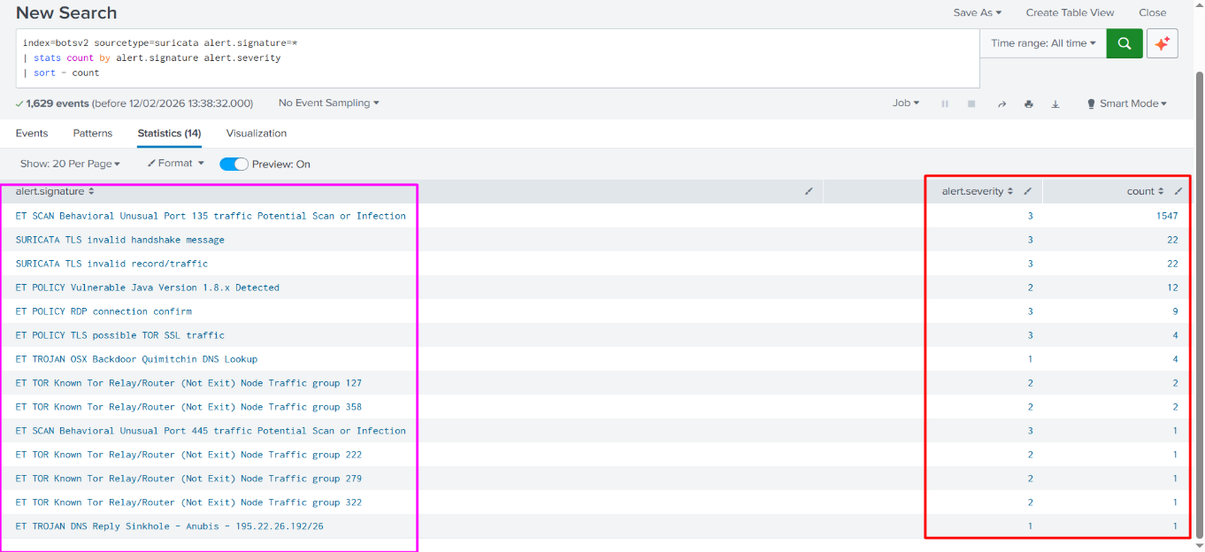
Intrusion Alerts by Severity
- This panel provides a severity-wise distribution of IDS alerts.
- It allows analysts to quickly assess the overall risk level of the environment.
- Severity-based visualization supports efficient alert triage and incident prioritization.
Scanning Activity (Many Attacks from Same Source)
- This section detects scanning behavior where multiple alerts originate from the same source IP.Such activity often indicates reconnaissance or port scanning attempts by attackers.
- SOC analysts use this panel to identify suspicious IPs and initiate blocking or investigation.
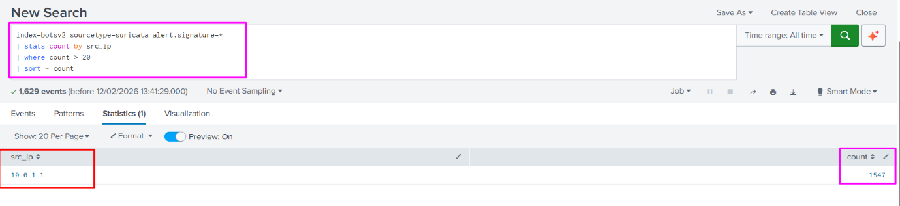
SPL Command: index=botsv2 sourcetype=suricata alert.signature=* | stats count by src_ip| where count > 20| sort – count
Scanning Activity by Source Location
- This panel correlates scanning activity with source location information.
- It helps identify geographical patterns of attack sources.
- This insight supports threat intelligence analysis and proactive defense planning.
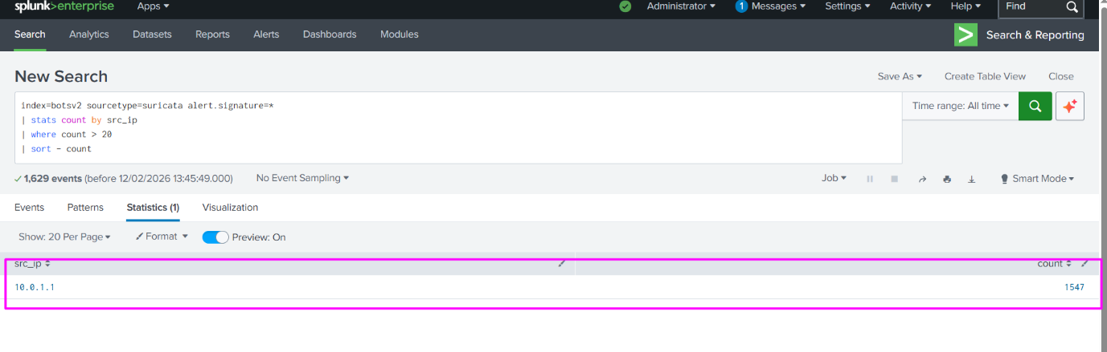
SPL Command: index=botsv2 sourcetype=suricata alert.signature=* | stats count by src_ip | where count > 20 | sort – count

IDS Log Analysis Fundamentals for SOC Analysts
Understanding IDS logs is a critical responsibility of a SOC analyst. Each IDS event contains multiple fields that help analysts detect, investigate, and respond to potential security threats. The following fields are essential for analyzing IDS alerts in Splunk, especially when using Suricata-based logs.

1. Timestamp
- The timestamp indicates the exact date and time when the IDS detected the suspicious activity.
- It is crucial for incident timeline reconstruction, correlation with other logs (firewall, system, authentication), and identifying attack patterns over time.
Example:
2026-02-01 10:35:42 — shows when a port scan or intrusion attempt occurred.
SOC Use Case:
Helps answer “When did the attack start and how long did it last?”

2. Source IP Address
The source IP represents the origin of the suspicious traffic, often the attacker’s IP address.
SOC analysts analyze this field to identify malicious hosts, repeated attackers, or internal compromised systems.
Example:
src_ip = 192.168.1.50 (internal) or src_ip = 45.33.32.156 (external attacker)
SOC Use Case:
Used for IP blocking, threat intelligence lookup, and identifying brute-force or scanning activity.

3. Destination IP Address
- The destination IP shows the target system or network asset that the attacker is attempting to access.
- This helps analysts determine which server, application, or endpoint is under attack.
Example:
dest_ip = 192.168.1.10 (web server)
SOC Use Case:
Helps answer “Which system is being targeted?” and assess business impact.

4. Protocol
The protocol field specifies the network protocol used during the suspicious activity.
Common protocols include TCP, UDP, ICMP, HTTP, or DNS.
Example:
protocol = TCP (used in port scans or exploit attempts)
SOC Use Case:
Helps identify attack type (e.g., ICMP flood, TCP SYN scan, HTTP attack).

5. Signature / Rule Name
The signature (or rule name) indicates which IDS rule triggered the alert.
It provides insight into the type of attack or suspicious behavior detected by Suricata or Snort.
Example:
ET SCAN Nmap Scripting Engine User-Agent Detected
SOC Use Case:
Helps classify attacks such as port scanning, brute force, malware traffic, or exploit attempts.

6. Severity
- Severity defines the risk level of the detected activity, usually categorized as Critical, High, Medium, Low, or Informational.
- SOC analysts use severity to prioritize alerts and focus on high-risk threats first.
Example:
severity = High
- 1 = high , 2= Medium, 3= low
SOC Use Case:
Supports alert triage and faster incident response in SOC operations.
7. Action (Allowed / Blocked)
- This field indicates whether the detected intrusion attempt was allowed or blocked by security controls.
- It helps determine if the attack successfully reached the target or was prevented.
Example:
action = allowed or action = blocked
SOC Use Case:
- Allowed → Requires investigation and possible mitigation
- Blocked → Confirms security controls are working
IDS Event Breakdown (Suricata Raw Log Analysis)
The following raw IDS event was generated by Suricata and ingested into Splunk for analysis.
Raw IDS logs contain structured fields that provide deep visibility into network activity, attacker behavior, and potential security threats. Understanding each field allows SOC analysts to accurately investigate alerts and make informed decisions.

Raw Event Overview
- This event represents a network-based intrusion alert triggered when Suricata detected unusual TCP traffic targeting a sensitive service port.
- The alert was generated based on a predefined detection rule and classified as medium severity, indicating suspicious behavior that may require monitoring or escalation.
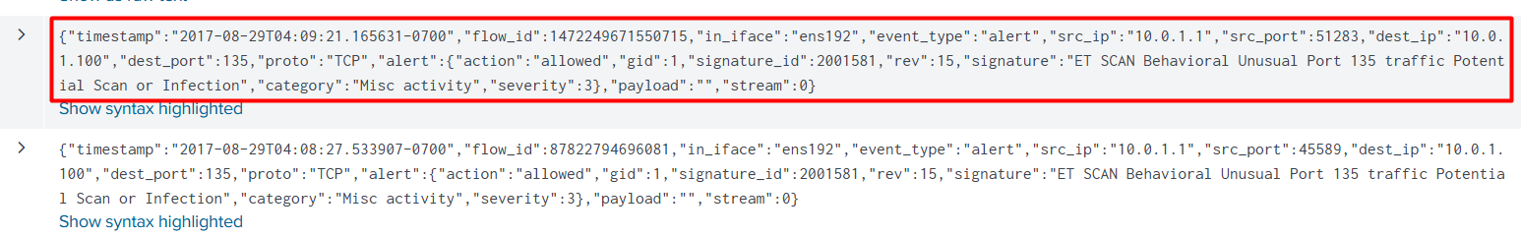
- Timestamp : 2017-08-29T04:09:21.165631-0700
- Source IP : 10.0.1.1
- Destination IP : 10.0.1.100
- Protocol : TCP
- Destination Port : 135
- Signature / Rule Name : ET SCAN Behavioral Unusual Port 135 traffic Potential Scan or Infection
- Severity : 3
- Action (Allowed / Blocked) : Allowed

Operational IDS Monitoring Through SPL Query Execution
- Custom SPL queries were executed on raw IDS logs ingested into Splunk to identify intrusion patterns and analyze alert behavior.
- Instead of relying only on predefined data models, raw log-based queries were used to gain full visibility into IDS events and ensure accurate threat analysis.
- This approach reflects real SOC operations, where analysts frequently work directly with raw security logs.

1. Raw Log-Based Query Analysis
- Raw Suricata logs were queried directly using the sourcetype to analyze IDS alerts at a granular level.
- This allows analysts to inspect original event fields such as source IP, destination IP, signature, and severity without abstraction.
- Working with raw logs improves accuracy and helps validate detections.
Example SPL Query:
index=botsv2 sourcetype=suricata event_type=alert

2. Filtering IDS Alerts by Severity
- Severity-based filtering was applied to prioritize alerts and focus on higher-risk security events.This helps SOC analysts reduce alert noise and quickly identify threats that require immediate attention.
- Severity filtering is essential for effective alert triage in SOC environments.
Example SPL Query:
index=botsv2 sourcetype=suricata alert.severity<=2
3. Identifying Repeated Attacks from the Same Source
- Repeated alerts from the same source IP were analyzed to detect scanning activity or brute-force attempts.
- Multiple alerts originating from a single IP within a short time frame often indicate reconnaissance or automated attack behavior.
- This analysis supports early threat detection and proactive response.
Example SPL Query:
index=botsv2 sourcetype=suricata event_type=alert
| stats count by src_ip| where count > 5 | sort - count

4. External vs Internal Attack Traffic Analysis
- IDS alerts were categorized as internal or external based on source IP address ranges.
This helps differentiate between insider threats, lateral movement, and external attacker activity.
- Understanding traffic origin is critical for determining attack intent and impact.
Example SPL Query:
index=botsv2 sourcetype=suricata event_type=alert
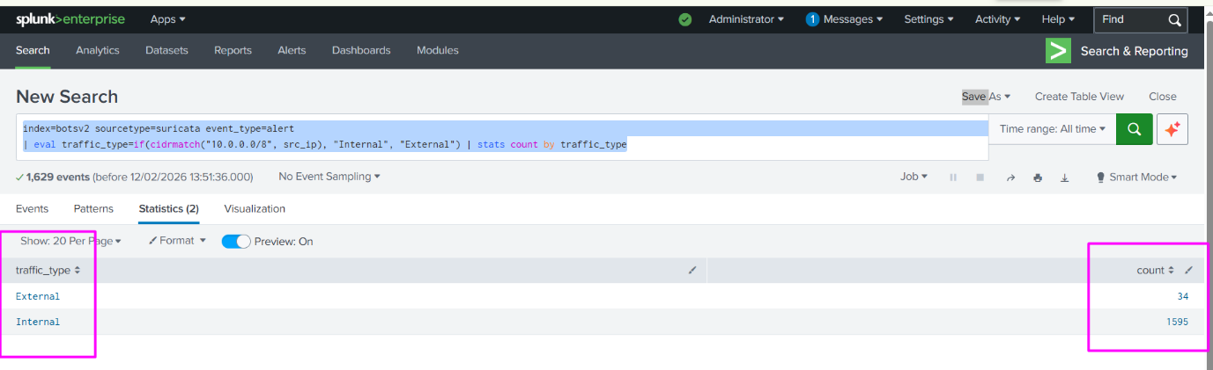
| eval traffic_type=if(cidrmatch("10.0.0.0/8", src_ip), "Internal", "External") | stats count by traffic_type

5. Analyzing Alert Behavior and Attack Patterns
- SPL queries were also used to analyze alert frequency, signatures, and targeted ports.
- This helps identify common attack techniques and frequently targeted services.
- Such analysis supports IDS rule tuning and continuous monitoring improvement.
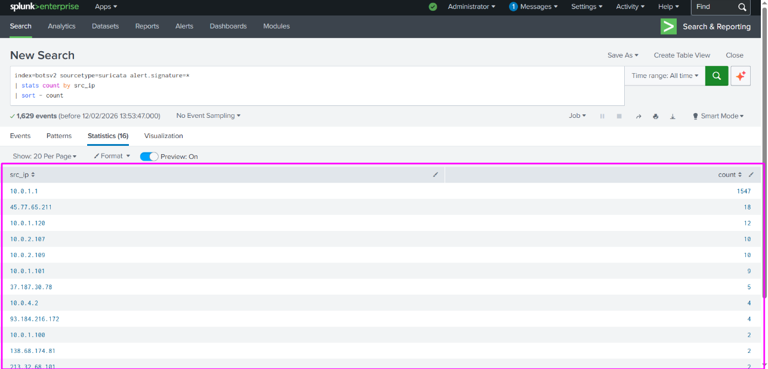
Example SPL Query: index=botsv2 sourcetype=suricata alert.signature=* | stats count by src_ip | sort - count

Alert Triage and Threat Visualization Using IDS Dashboards
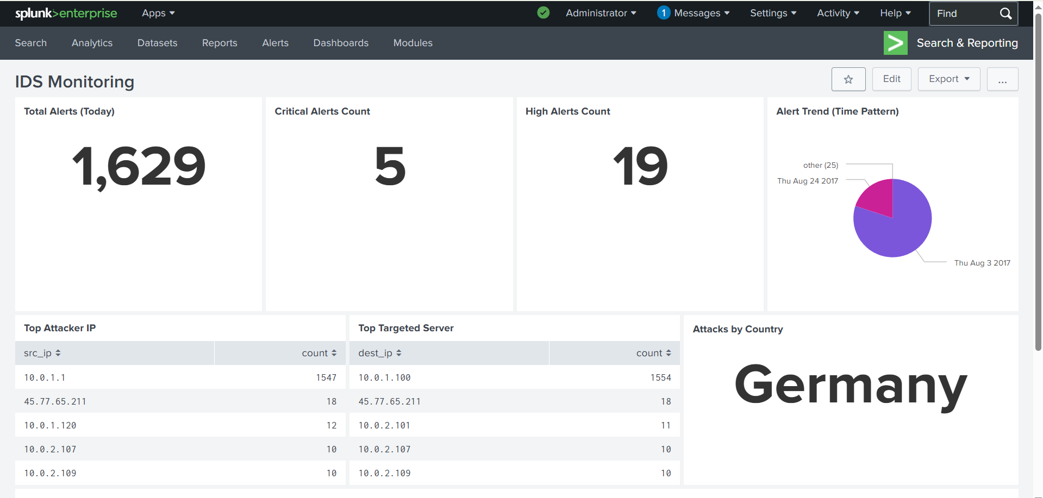
Alert triage and threat visualization were implemented using IDS dashboards in Splunk, leveraging SPL-based panels built on raw Suricata alert data. The dashboards classify IDS events by severity, signature, protocol, and action (allowed or blocked), enabling efficient prioritization of high-risk alerts. Aggregation and statistical visualizations were used to identify repeated attack patterns from the same source IP, which often indicate scanning or automated intrusion attempts. Traffic origin analysis was performed by correlating source IP ranges to distinguish internal lateral movement from external attacker activity. This structured visualization approach enhances situational awareness, supports rapid alert triage, and aligns with real-world SOC incident investigation workflows.

- This dashboard simulates real-world SOC Level-1 monitoring activities including alert triage, threat categorization, anomaly detection, and attack source analysis.
IDS Monitoring Dashboard Structure:
- Total Alerts (Today) :
index=botsv2 sourcetype=suricata alert.signature=* | stats count as Total_Alerts
- Critical Alerts Count :
index=botsv2 sourcetype=suricata alert.severity=1 | stats count as Critical_Alerts
- High Alerts Count :
index=botsv2 sourcetype=suricata alert.severity=2 | stats count as High_Alerts
- Alert Trend (Time Pattern) :
index=botsv2 sourcetype=suricata alert.signature=* | timechart count by alert.severity
- Top Attacker IP:
index=botsv2 sourcetype=suricata alert.signature=* | stats count by src_ip | sort - count | head
- Top Targeted Server:
index=botsv2 sourcetype=suricata alert.signature=* | stats count by dest_ip | sort - count | head 5
- Scanning Activity Detection:
index=botsv2 sourcetype=suricata alert.signature=* | stats dc(dest_ip) as unique_targets count by src_ip | where unique_targets &gt; 10 | sort - unique_targets
- Attacks by Country
index=botsv2 sourcetype=suricata alert.signature=* | iplocation src_ip | stats count by Country | sort - count

Security Monitoring Limitation and Mitigation
During the dashboard development phase, some panels were configured to reference the Intrusion_Detection data model, which is typically available when Splunk Enterprise Security is enabled. In this lab-based environment, Splunk Enterprise Security was not installed or activated, resulting in the unavailability of the required data model. Due to this limitation, a few dashboard panels displayed data model–related errors.
To mitigate this constraint, security analysis was performed directly on raw IDS logs generated by Suricata using custom SPL queries. By querying raw events instead of relying on prebuilt data models, all critical analysis tasks—such as alert severity filtering, source IP analysis, detection of repeated attacks, and identification of internal versus external traffic—were successfully completed. This approach ensured full visibility into intrusion activity without loss of analytical accuracy.
This mitigation strategy reflects real-world SOC operations, where analysts often need to adapt to tool or environment limitations. Working effectively with raw log data demonstrates strong foundational SOC skills and the ability to perform threat analysis independently of advanced SIEM features.

Incident Analysis Summary
During the analysis of IDS logs in Splunk, multiple intrusion attempts were observed, including scanning activities and unusual traffic targeting specific network ports. These attacks occurred repeatedly from the same source IPs, indicating automated or reconnaissance-based behavior rather than one-time events. Most alerts were classified as medium severity, with a few low-severity and informational alerts also recorded. The repeated nature and targeting pattern of the traffic indicate suspicious activity, although no confirmed system compromise was detected. Overall, the incidents required monitoring and correlation but did not escalate to a critical security breach.

SOC Analyst Actions During IDS Alert Investigation
Alert Validation
- Each IDS alert was first validated by reviewing raw event details such as source IP, destination IP, port, protocol, and signature in Splunk.
- This step helped confirm whether the alert was a true security event or a false positive.
Only relevant alerts were taken forward for further investigation.

Severity Classification
- Validated alerts were classified based on severity level, attack type, and potential impact on the network.
- High and medium severity alerts were prioritized, while low and informational alerts were monitored for patterns.
- This classification ensured efficient alert triage and time-based prioritization.

Identifying Scanning Behavior
- Repeated alerts from the same source IP targeting multiple ports or systems were analyzed to detect scanning behavior.
- Such patterns usually indicate reconnaissance or automated attack attempts.
- Identifying scanning activity helps SOC analysts act before an attack escalates.

Recommendation for Blocking IPs
- Source IPs showing repeated suspicious behavior were flagged for blocking at the firewall or perimeter security devices.
- Blocking recommendations were made only after confirming malicious patterns to avoid disrupting legitimate traffic.
- This proactive step helps reduce attack surface and prevent further intrusion attempts.

SOC Escalation and Handover Process
- Alerts that showed repeated activity, higher severity, or potential compromise indicators were escalated to the L2 SOC team.
- Escalation included providing detailed evidence such as log samples, timestamps, and analysis summary.
- This ensured smooth handover and faster incident resolution.

Conclusion
This project demonstrates my ability to perform effective IDS log analysis and security monitoring in a SOC environment using Splunk. Through hands-on analysis of raw IDS logs, SPL query execution, and dashboard creation, I gained practical experience in alert triage, threat detection, and incident investigation. The project reflects real-world SOC workflows, including monitoring posture design, severity-based alert prioritization, and response planning. Overall, it showcases my readiness for an entry-level SOC Analyst role and my ability to contribute to security operations.

